SPECIAL EDUCATIONAL NEEDS and DISABILITY POLICY – DRAFT
The Special Education Needs Co-ordinator is – Mrs Ruth Randall
The Governor with responsibility for Special educational needs is- Mrs P Reynolds

Definition of Special Education Needs (SEND)
The SEND Code of Practice (DfES, 2014) says pupils have a learning difficulty if they
· have a significantly greater difficulty in learning than the majority of others of the same age; or
· have a disability, which prevents or hinders them from making use of educational facilities of a kind generally provided for others of the same age in mainstream schools or mainstream post-16 institutions.
A child under compulsory school age has special educational needs if they fall within the definition at (a) or (b) above or would so do if special educational provision was not made for them.
(Clause 20 Children and Families Bill 2014).

Vision
At Southdale Junior School, we are committed to the academic and personal development of all pupils regardless of ability. We recognise the diverse and individual needs of all of our pupils and take into account the additional support required by those children with Special Educational Needs and Disabilities (SEND).
Southdale Junior School adopts a whole school approach to Special Educational Needs and Disabilities. All staff work together to ensure the inclusion of all pupils. We are committed to ensuring that students with SEND achieve their full potential.
We believe in positive intervention: removing barriers to learning: raising expectations and accelerating levels of achievement.
· All children with SEND have the right to a broad and balanced curriculum, relevant and differentiated, which demonstrates progression and coherence.
· All children with SEND can learn and make progress, even if only in very small steps, and deserve to have their progress regularly assessed, recognised and celebrated.
· All teachers are teachers of SEND.
· All children with SEND will be valued as full members of the school community.
· All children with SEND and their parents have the right to be involved in assessing progress and determining goals. A person centred partnership should exist between the pupil, parents and the school.
This SEND Policy details how Southdale Junior School will do its best to ensure that the necessary provision is made for any pupil who has special educational needs and those needs are made known to all who are likely to teach them.
The Special Educational Needs Co-ordinator, Mrs Ruth Randall, is responsible for the operation of this policy. She is assisted by the team of Teachers, HLTAs and ETAs.
Southdale Junior School considers all teachers to be teachers of pupils with SEND.
We will use our best endeavours to ensure that teachers in the school are able to identify and provide for those pupils who have special educational needs, which will allow them to be fully included in all the activities of the school alongside their peers. This provision should be reasonably practical and compatible with the child receiving the special educational provision they need and the efficient education of the pupils with whom they are educated.

Admission Arrangements
The admissions arrangements for all pupils are in accordance with national legislation, including the Equality Act 2010. This includes pupils with any level of SEND: those with a statement or EHCP plan and those without. Prospective parents of a child with SEND will be welcomed into school and assured that Southdale Junior School will provide appropriate support for the education, needs and well-being of their child.
The SENCo will gather all of the SEND paperwork and relevant information from feeder primary schools and any agencies working with the child as soon as possible. If the pupil is making a transition from another school, a meeting may be set up between the feeder primary schools and the SENCo to aid a smooth transition and to make sure that the pupil’s needs are being met.
In addition, the SENCo will work closely with SEND Year 6 pupils during the spring and summer terms prior to transfer.
When face-to-face meetings are not possible, contact will be made via telephone and/or email to make sure that there is a good understanding of the type of provision that is required.

A Person Centred Approach
Young people with special educational needs often have a unique knowledge of their own requirements as well as views about what sort of help they would like in order for them to make the most of their education.
At Southdale Junior School, pupils will be encouraged to participate in all the decision-making processes and contribute to the assessment of their needs, their review and transition processes. Their views will be sought at every stage and we shall encourage them to take responsibility for their own learning.

Partnership with Parents
Southdale Junior School will have regard to the SEND Code of Practice (2014) when carrying out its duties toward all pupils with special educational needs and ensure that parents are notified of a decision by the school that SEND provision is being made for their child. Partnership with parents plays a key role in enabling children and young people with SEND to achieve their potential. We recognise that parents hold key information and have knowledge and experience to contribute to the shared view of a child’s needs and the best ways of supporting them. All parents of children with special educational needs will be treated as partners and supported to play an active and valued role in their children’s education.
Wakefield SEND (IASS) Information, advice and support service provides information and support to parents of pupils with SEND. A wide range of information and advice may be obtained by contacting this independent service.
Contact details are as follows:
Wakefield SEND-IASS
KIDS
Office Suite 7
Bizspace Office Park
Denby Dale Road
Wakefield
WF2 7AZ
01924 379015

Identification
Assessment is a continuing process that can identify pupils who may have SEND. The school will measure children’s progress by referring to:
· Baseline testing-spelling and comprehension
· Evidence from teacher observation and assessment
· Their performance against age related expectations at the end of a key stage.
· Standardised screening or assessment tools.
· Other baseline testing

English as an additional language
The identification and assessment of the special educational needs of young people whose first language is not English requires particular care. Where there is uncertainty about an individual, the school will look carefully at all aspects of a pupil’s performance in different subjects to establish whether the problems they have in the classroom are due to limitations in their command of the language that is used there or arise from Special Educational Needs. We will provide heritage language support to help us assess whether or not a child with English as and additional language has SEND. Children who have English as a second language will not be classed as SEND.

All teachers are teachers of pupils with special educational needs
Teaching such pupils is a whole-school responsibility, requiring a whole-school response. Central to the work of every class and every subject is a continuous cycle of planning, teaching, assessment and evaluation that takes account of the wide range of abilities, aptitudes and interests of the pupils. The majority of pupils will learn and progress within these arrangements. However, for pupils with special educational needs, there may be a need to provide an enhanced level of provision that supports and enhances their learning abilities.

Graduated response
Southdale Junior School adopts a graduated whole school response to meeting special educational needs that requires the initial use of classroom and school resources before bringing specialist expertise to bear on the difficulties that a pupil is experiencing. When a young person is identified as having Special Educational Needs, the school will intervene.
If a pupil is known to have special educational needs when they arrive at school, the SENCO, teachers and Learning Support staff will:
· Use information from the feeder school to provide an appropriate curriculum for the pupil and focus attention on action to support the pupil within the class.
· Ensure that ongoing observation and assessment provides feedback about pupil’s achievements to inform future planning of the pupil’s learning.
· Ensure opportunities for the pupil to show what they know and understand
· Involve the pupil in planning and agreeing targets to meet their needs.
· Involve parents in developing a joint learning approach at home and in school.

Monitoring Pupil Progress
Teachers may conclude that the strategies they are currently using with a pupil are not resulting in the pupil learning as effectively as possible. In these circumstances, they will consult the SENCO to consider what else might be done. The starting point will always be a review of the strategies being used and the way in which these might be developed. Evaluation of the strategies in place may lead to the conclusion that the pupil requires help over and above that which is normally available within the particular class or subject.
The key test of the need for action is evidence that current rates of progress are inadequate. Adequate progress can be defined in number of ways. It might, for instance, be progress which:
· Closes the attainment gap between the pupil and the pupil’s peers.
· Prevents the attainment gap growing wider.
· Is similar to that of peers starting from the same attainment baseline, but less than that of the majority of peers.
· Matches or betters the pupil’s previous rate of progress.
· Ensures access to the full curriculum.
· Demonstrates an improvement in self-help, social or personal skills.
· Demonstrates improvements in the pupil’s behaviour.
· Is likely to lead to appropriate accreditation.
· Is likely to lead to participation in further education, training and/or employment.
When a pupil is identified as having special educational needs, Southdale Junior School will provide interventions that are additional to or different from those provided as part of the school’s usual differentiated curriculum. This intervention will be described as SEND support. The level of additional intervention and support will depend on the individual pupil need.

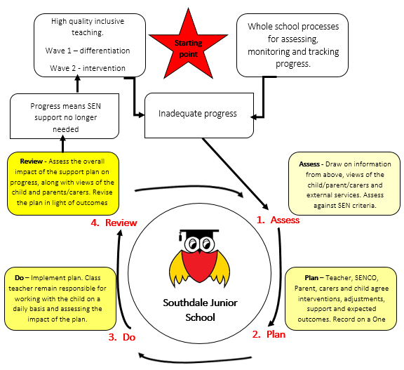
The triggers for intervention could be concern, underpinned by evidence, about a pupil who, despite receiving differentiated learning opportunities:
· Makes little or no progress even when teaching approaches are targeted particularly in a pupil’s identified area of weakness.
· Shows signs of difficulty in developing literacy or mathematics skills that result in poor attainment in some curriculum areas.
· Has sensory or physical problems, and continues to make little or no progress despite the provision of specialist equipment.
· Has communication and/or interaction difficulties, and continues to make little or no progress despite the provision of a differentiated curriculum.
· If we conclude, after consulting parents, that a pupil may need further support to help them progress, we will consider our reasons for concern alongside any information about the pupil already available to the school.
· The SENCO will support the assessment of the pupil, assisting in planning future support for the pupil in discussion with colleagues and monitoring the action taken. The pupil’s teacher will remain responsible for working with the pupil, for assisting in the planning of an individualised programme and for the delivery of such a programme.
· In some cases outside professionals from health or social services may already be involved with the child. In such instances it is good practice for these professionals to liaise with the school and keep them informed of their input. If these professionals have not been working with the school, the SENCO with the parent’s permission will contact them.

Nature of Intervention
The SENCO and the pupil’s teacher, in discussion with the child’s parents, will decide on the action needed to help the pupil to progress in the light of their earlier assessment.
This might be:-
· To provide different learning materials or special equipment.
· To introduce some group or individual support.
· To devote adult time to devising the nature of the planned intervention and to monitoring its effectiveness.
· To undertake staff development and training aimed at introducing more effective strategies.
· Access to LA support services for advice on strategies or equipment or for staff training.
· To provide effective intervention using advice from external agencies.

The wave model below outlines Southdale Junior School’s approach towards intervention.

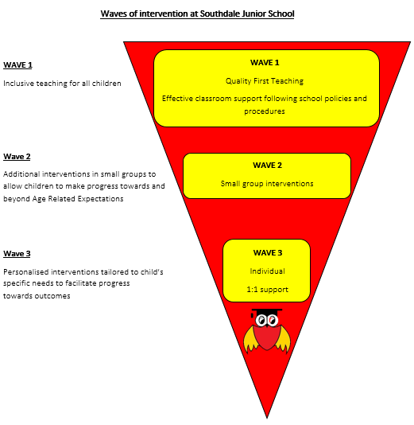

A Graduated Approach-Wave Model –Triggers

WAVE 1 - Quality First Teaching
· Any pupils who are falling significantly outside of the range of expected academic achievement in line with predicted performance indicators and grade boundaries will be monitored.
· Once a pupil has been identified as possibly having SEND they will be closely monitored by staff in order to gauge their level of learning and possible difficulties
· The pupil’s class teacher will take steps to provide differentiated learning opportunities that will aid the pupil’s academic progression and enable the teacher to better understand the provision and teaching style that needs to be applied.
· The SENCO will be consulted as needed for support and advice and may wish to observe the pupil in class.
· If a pupil has recently been removed from the SEND list they may also fall into this category, as continued monitoring will be necessary.
· Parents will be informed of any concerns and the school action-taking place. Parents are encouraged to share information and knowledge with the school.
· Concerns by teachers and/or parents will be investigated.
· Pupils will only be placed on the SEND register once the need is confirmed. Pupil drop in and progress meetings are used to monitor and assess the progress being made by the pupil. The frequency of these meetings is dependent on the individual pupil’s needs and progress being made.

Wave 2 –SEND Support
· This recognises pupils who are identified as requiring additional and different help as well as the regular differentiated curriculum. Under Wave 2 provision, the school puts provision in place without resource to regular external advice or additional resources provided by the local authority.
· Class teachers collaborate with the SENCO on evidence gathering and identification.
· Once the SENCO has been notified, she will make their own assessment through reviewing the evidence of identification supplied by the teacher and/or through observation.
· An action plan is drawn up, detailing provision. Provision is monitored regularly, evaluated and, if necessary, adjusted.

Wave 3- SEND Support
· When a pupil has been identified as having SEND and steps have been taken for provision Under Wave 2 SEND support but the pupil has not progressed as expected, the school will consider taking steps under Wave 3 SEND Support.
· Following the school’s previous assessment under Wave 2, where appropriate external professionals will be called to make their own assessments of the pupil and provide support in the planning of extended provision, continued assessment and revised action points.
· The school will make every effort to ensure that advice from the external agencies is put into practice as swiftly as possible and will keep in regular contact with support services and parents regarding progress
· External input can involve support and intervention, for example through specialist teaching or therapy. The school will coordinate this and, with the external professional, monitor, review and evaluate the effectiveness of interventions.

Links with Outside Agencies
Links with external agencies are vital to ensure that we provide the highest levels of support for our pupils with SEND. Any one of the support services can raise concerns about a pupil. This will be brought to the attention of the SENCO and the pupil’s parents. A request for help from external services is likely to follow a decision taken by the SENCO, colleagues, in consultation with parents. External support services will usually see the child, so that they can advise staff on strategies and provide more specialist assessments that can inform planning and the measurement of a pupil’s progress, give advice on the use of new or specialist strategies or materials, and in some cases provide support for particular activities.

School Request for Statutory Assessment-Education, Health and Care plan.
For a few pupils, the help given by Southdale Junior School intervention both in school and from outside agencies may not be sufficient to enable the pupil to make adequate progress. It will then be necessary for the school, in consultation with the parents and any external agencies already involved, to consider whether to ask the LA to initiate a statutory assessment. Where a request for a statutory assessment is made to the LA, the pupil will have demonstrated significant cause for concern and is making little or no progress while accessing additional interventions.
We will provide written evidence as required by Wakefield LA detailing:
· The intervention and provision map records.
· Individual pupil profile – One Page Profile
· Records of regular reviews and their outcomes.
· National Curriculum level attainments.
· Other assessment data.
· Written reports from an advisory specialist support teacher or an educational psychologist if available.
· Views of the parents and of the pupil.
· The involvement of any other professionals.
· Any known involvement by the social services or education welfare service.
· Education Advice: providing information relating to concerns, difficulties and all strategies and interventions implemented.

Depending upon the outcome of such a request, statutory assessment may take place. Parents will be offered support from the SENCO to help them through the statutory assessment process. Following statutory assessment, the LA may issue a statement of the child’s special educational needs.

Annual Review of a statement/Education, Health and Care plan (EHCP)
All statements and Education, Health and Care plans will be reviewed at least annually with the parents, the pupil, the LA and Southdale Junior School to consider whether any amendments need to be made to the description of the pupil’s needs or to the special educational provision specified in the statement. The annual review will focus on what the child has achieved as well as on difficulties that need to be resolved.
The annual review held in year 6 is particularly significant in preparing for the pupil’s transition to KS3.

One Page Profiles OPP
Strategies employed to enable the pupil to progress will be recorded within a One Page Profiles (OPP). The OPP will include information about:
· What the child needs to support them to learn
· Information about their interests and strengths
· Possible resources/techniques and strategies to use in class
· When the plan has been reviewed
· Their outcomes (targets)
· Information on what school does to support the child
· Any external support
· How parents can support their child at home
The pupil will take part in the development of their individual pupil profile where appropriate. Pupil profiles will be reviewed on an at least termly basis to ensure that pupil progress can be tracked effectively.

Evaluating the Success of the SEND Policy
The success of Southdale Junior School’s SENDD provision is evaluated through:
· The monitoring of classroom practice by the SENDCO and senior Leadership.
· The progress made by SEND pupils
· The performance of SEND pupils in nationally accredited tests and examinations compared with like children
· The analysis of pupil tracking and testing data for both individual pupils and cohorts.
· The monitoring of policy and practice by the SEND Governor.
· Comments from parents and pupils
· Parental involvement, especially attendance at reviews.
· Website
· Information will be collated in order to self-evaluate the success of SEND support and provision, building on success and looking for areas for improvement and innovation.

The role of the SENCO
The SENCO, in collaboration with the Head Teacher and Governing body, plays a key role in helping to determine the strategic development of the SEND policy and provision in the school to raise the achievement of pupils with SEND. The key responsibilities of the SENCO will include:
· Overseeing the day-to-day operation of the school’s SEND policy.
· Liaising with and advising fellow teachers.
· Advising on a graduated approach to providing SEND support.
· Liaising with parents of pupils with SEND
· Managing the Learning Support team with interventions
· Coordinating provision for pupils with SEND
· Overseeing the records on all pupils with SEND
· Contributing to the in-service training of staff
· Liaising with external agencies including the LA’s support and educational psychology services, health and social services and voluntary bodies.
· Developing link with other school/sharing best practice.

Links with other schools
Working collaboratively with other schools is another way that we ensure that provision for our pupils with SEND is effective. We are proud to have strong links with EOCT who we liaise with regularly to continue to develop outstanding practice. The work of the trust of schools is aimed at raising achievement and extending opportunities for children with SEND.

Complaints Procedures
Complaints concerning any aspects of Southdale Junior School’s SEND Policy should be addressed to the Head teacher.

Useful documents
Special Educational Needs Code of Practice. DfES September 2014
Children and Families Act 2013
Other information may be found on the Department for Education and Skills website at: www.dfes.gov.uk/SEND

